**Lab 03**

**[CLO-01 & 3, PLO-01& 9, P3(Guided Response) & A2(Responding), Rubric (Hardware Configurations) & (Team Work)]**

**Try to understand the how electricity bill is calculated and understand how to wire single phase distribution board**

**Introduction to Electricity Consumption:**

Electricity consumption refers to the amount of electrical energy used by various devices and appliances in homes, businesses, and industries. It is measured in kilowatt-hours (kWh), representing the energy consumed when a 1,000-watt device (1 kilowatt) operates for one hour. Understanding electricity consumption is essential for managing energy costs and environmental impact. By calculating kWh usage and monitoring electrical devices, individuals can make informed decisions to reduce energy consumption and lower electricity bills. It's a fundamental concept in promoting energy efficiency and sustainability.

**Understanding Kilowatt-Hours (kWh):**

A kilowatt-hour (kWh) is a unit of measurement used to quantify electrical energy consumption. It represents the amount of energy used when a 1,000-watt device (1 kilowatt) operates for one hour. To illustrate this concept, let's consider an example:

Imagine you have a 100-watt light bulb. If you leave this light bulb on for 10 hours, it will consume 1,000 watt-hours, which is equivalent to 1 kilowatt-hour (1 kWh). This means that your electricity bill will be charged for 1 kWh of energy usage for running the 100-watt light bulb continuously for 10 hours.

In summary, a kilowatt-hour (kWh) is a measure of energy consumption that helps us understand how much electricity we use, and it's commonly used in electricity billing to determine costs based on the amount of energy consumed over time.

$$1 KWh=1000 watt energy consumed in one hour=1 Unit$$

**Example 1: A 100-Watt Light Bulb for 5 Hours**

* Calculate the energy consumption for a 100-watt light bulb operating for 5 hours:
  + Energy (kWh) = Power (kW) x Time (hours)
  + Energy (kWh) = 100W x 5 hours = 500Wh = 0.5 kWh
  + Units = 500/1000 = 0.5 Unit
* So, the 100-watt light bulb consumes 0.5 kWh when used for 5 hours.

**Example 2: A 1,500-Watt Space Heater for 10 Hours**

* Calculate the energy consumption for a 1,500-watt space heater running for 10 hours:
  + Energy (kWh) = Power (kW) x Time (hours)
  + Energy (kWh) = 1500W x 10 hours = 15000Wh = 15 kWh
  + Unit = 15000/1000 = 15 units
* Thus, a 1,500-watt space heater consumes 15 kWh when used for 10 hours.

In many electricity billing systems, 1 kilowatt-hour (kWh) is often referred to as 1 unit. So, in these examples, the 100-watt light bulb would be billed as 0.5 units for 5 hours of use, and the 1,500-watt space heater would be billed as 15 units for 10 hours of use. Understanding these calculations can help students become more aware of their electricity consumption and make informed decisions to manage their energy usage and costs.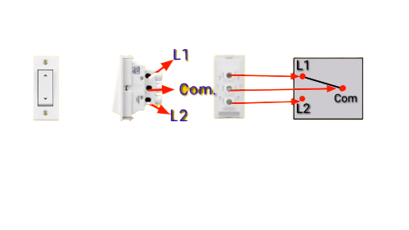

**Lab Task 01: Practice** the wiring of given distribution board for 5 rooms, 1 kitchen, 2 bathrooms in the house and **Comply** with the safety guidelines while dealing with high voltage setup and assist each other in group related tasks.

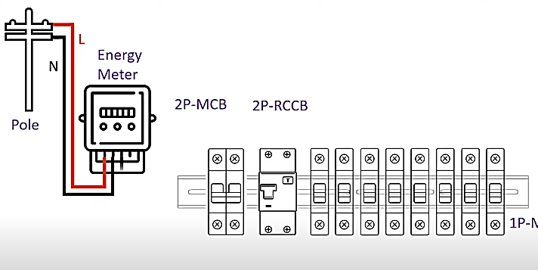

**[CLO-01 & 3, PLO-01& 9, P3(Guided Response) & A2(Responding), Rubric (Hardware Configurations) & (Team Work)]**

**Rubric:**

|  |  |  |  |  |
| --- | --- | --- | --- | --- |
| **Marks** | **1** | **2** | **3** | **4** |
| **Hardware Configurations** | The hardware configuration is not as per guidelines and requirements are not met | Some section of hardware configuration is correct | Most section of hardware configuration is correct and understands it well | The hardware configuration is properly done, and have good understanding about it |

|  |  |  |  |  |
| --- | --- | --- | --- | --- |
| **Marks** | **1** | **2** | **3** | **4** |
| **Team Work** | Rarely listens to, shares with, and supports the efforts of others. Often is not a good team member. | Often listen to, shares with and supports the efforts of others, but sometimes is not good team member. | Usually listen to, shares with, and supports the efforts of others. Usually, respectful and listening actively | Almost always listens to, shares with and supports the efforts of others. Tries to keep people working well together. |

**Lab Task 02: Try** to Calculate how many units are consumed in a day by using a 100-watt light bulb for 5 hours, a 1,500-watt microwave for 10 minutes, a 500-watt TV for 3 hours, and a 1,200-watt refrigerator running continuously.

1. **100-Watt Light Bulb for 5 Hours**:
   * Power (kW) = 100 watts / 1,000 = 0.1 kW
   * Energy (kWh) = Power (kW) x Time (hours) = 0.1 kW x 5 hours = 0.5 kWh
2. **1,500-Watt Microwave for 10 Minutes**:
   * First, convert minutes to hours: 10 minutes / 60 = 0.167 hours
   * Power (kW) = 1,500 watts / 1,000 = 1.5 kW
   * Energy (kWh) = Power (kW) x Time (hours) = 1.5 kW x 0.167 hours = 0.25 kWh
3. **500-Watt TV for 3 Hours**:
   * Power (kW) = 500 watts / 1,000 = 0.5 kW
   * Energy (kWh) = Power (kW) x Time (hours) = 0.5 kW x 3 hours = 1.5 kWh
4. **1,200-Watt Refrigerator Running Continuously**:

* Energy (kWh) = Power (kW) x Time (hours)
* Energy (kWh) = 1.2 kW x 24 hours = 28.8 kWh

Total Energy Consumption in a Day = 0.5 kWh (light bulb) + 0.25 kWh (microwave) + 1.5 kWh (TV) + 28.8 kWh (refrigerator) = 31.05 kWh

Therefore, the total energy consumption in a day for these appliances is 31.05 kilowatt-hours, which can also be expressed as 31.05 units.

* **Calculate the units consumed by a 2,000-watt space heater running for 8 hours a day during the winter month and the units consumed by a 1,500-watt air conditioner used for 6 hours daily in the summer.**
* **Calculate the units and cost associated with using a 60-watt incandescent bulb for 5 hours per day for a month compared to using a 10-watt LED bulb for the same duration.**

**[CLO-01, PLO-01, P3(Guided Response), Rubric (Hardware Configurations)]**

**Rubric:**

|  |  |  |  |  |
| --- | --- | --- | --- | --- |
| **Marks** | **1** | **2** | **3** | **4** |
| **Hardware Configurations** | The hardware configuration is not as per guidelines and requirements are not met | Some section of hardware configuration is correct | Most section of hardware configuration is correct and understands it well | The hardware configuration is properly done, and have good understanding about it |

**Lab Report Rubric:** *must be submitted in next lab***.**

|  |  |  |  |  |
| --- | --- | --- | --- | --- |
| **Marks** | **1** | **2** | **3** | **4** |
| **Lab Report** | The lab report does not follow the guidelines for formatting. | Presents some sections of the lab in the correct order. Three or more sections are not in the correct order; missing heading or title; | Presents most sections of the lab in the correct order, one or two sections may not be in the correct order; heading or title missing or not complete; | Presents all the sections of the lab in the correct order with correct formatting: includes correct heading, section headings and title of lab; |

**Scenario 1: Space Heater in Winter and Air Conditioner in Summer**

1. **Space Heater (Winter):**
   * Power (kW) = 2,000 watts / 1,000 = 2 kW
   * Time (hours) = 8 hours per day
   * Energy (kWh) = Power (kW) x Time (hours) = 2 kW x 8 hours = 16 kWh per day
   * For one month (assuming 30 days): 16 kWh/day x 30 days = 480 kWh
2. **Air Conditioner (Summer):**
   * Power (kW) = 1,500 watts / 1,000 = 1.5 kW
   * Time (hours) = 6 hours per day
   * Energy (kWh) = Power (kW) x Time (hours) = 1.5 kW x 6 hours = 9 kWh per day
   * For one month (assuming 30 days): 9 kWh/day x 30 days = 270 kWh

**Scenario 2: Incandescent Bulb vs. LED Bulb**

1. **Incandescent Bulb (60-Watt) for 5 Hours per Day for a Month:**
   * Power (kW) = 60 watts / 1,000 = 0.06 kW
   * Time (hours) = 5 hours per day
   * Energy (kWh) = Power (kW) x Time (hours) = 0.06 kW x 5 hours = 0.3 kWh per day
   * For one month (assuming 30 days): 0.3 kWh/day x 30 days = 9 kWh
2. **LED Bulb (10-Watt) for 5 Hours per Day for a Month:**
   * Power (kW) = 10 watts / 1,000 = 0.01 kW
   * Time (hours) = 5 hours per day
   * Energy (kWh) = Power (kW) x Time (hours) = 0.01 kW x 5 hours = 0.05 kWh per day
   * For one month (assuming 30 days): 0.05 kWh/day x 30 days = 1.5 kWh